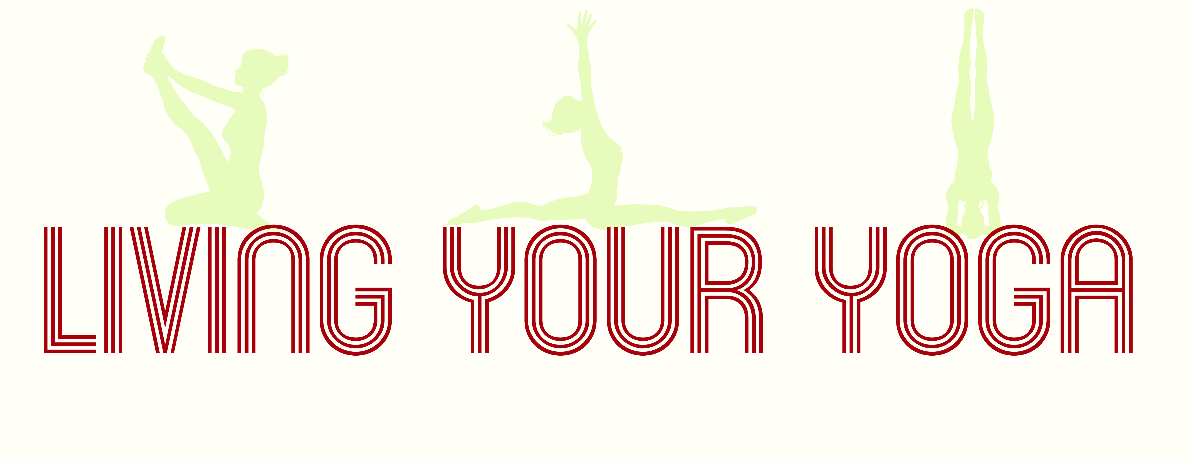

Well-Woman Health Questionnaire

Name:
Date of Birth:
Address:

Mobile Number:
Email Address:
Emergency Contact Name:
Emergency Contact Number:

Doctors Name:
Surgery Telephone Number:
Surgery Address:

Menopause Symptoms & Medication or Practices used to help with symptoms:

Other Health Conditions/Details (including pregnancies/operations/injuries):

Are you on any other Medication? If so, please provide details:

Food/General Allergies:

Yoga Experience:

What do you hope to gain from your Well-Woman Yoga Practice?

I declare that the information I have given here is correct and as far as I am aware I can participate in yoga classes/1:1 sessions.
I understand that it is my responsibility to inform the teacher of any health situation/ problems.
I understand that my body is my responsibility, and that should I be uncomfortable or in pain during an exercise I need to talk the yoga practitioner at the time so that suitable variations can be provided.
I understand that this form is strictly confidential, and is solely for the use of the yoga practitioner to help provide a safe environment within classes & 1:1 sessions.

Signed:

Print Name:

Date:

